**Assignment No: 1**

**Q1. a) Setup/Install the MySQL database server on your local machine. Include the screenshot(s). (25 pts)**

**b) Setup/Install a MySQL client on your local machine. You can install MySQL Workbench (a desktop client application) or phpMyAdmin (a web-based client application). Include the screenshot(s). (25 pts)**

**Tips: You’ll need to install XAMPP if you want to setup phpMyAdmin. XAMPP also includes the MySQL server package**

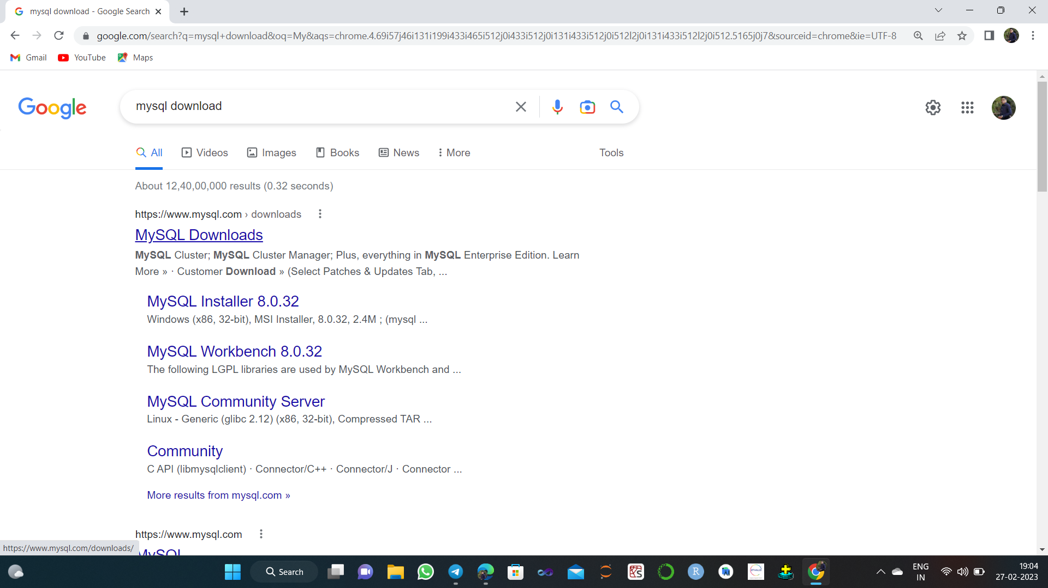

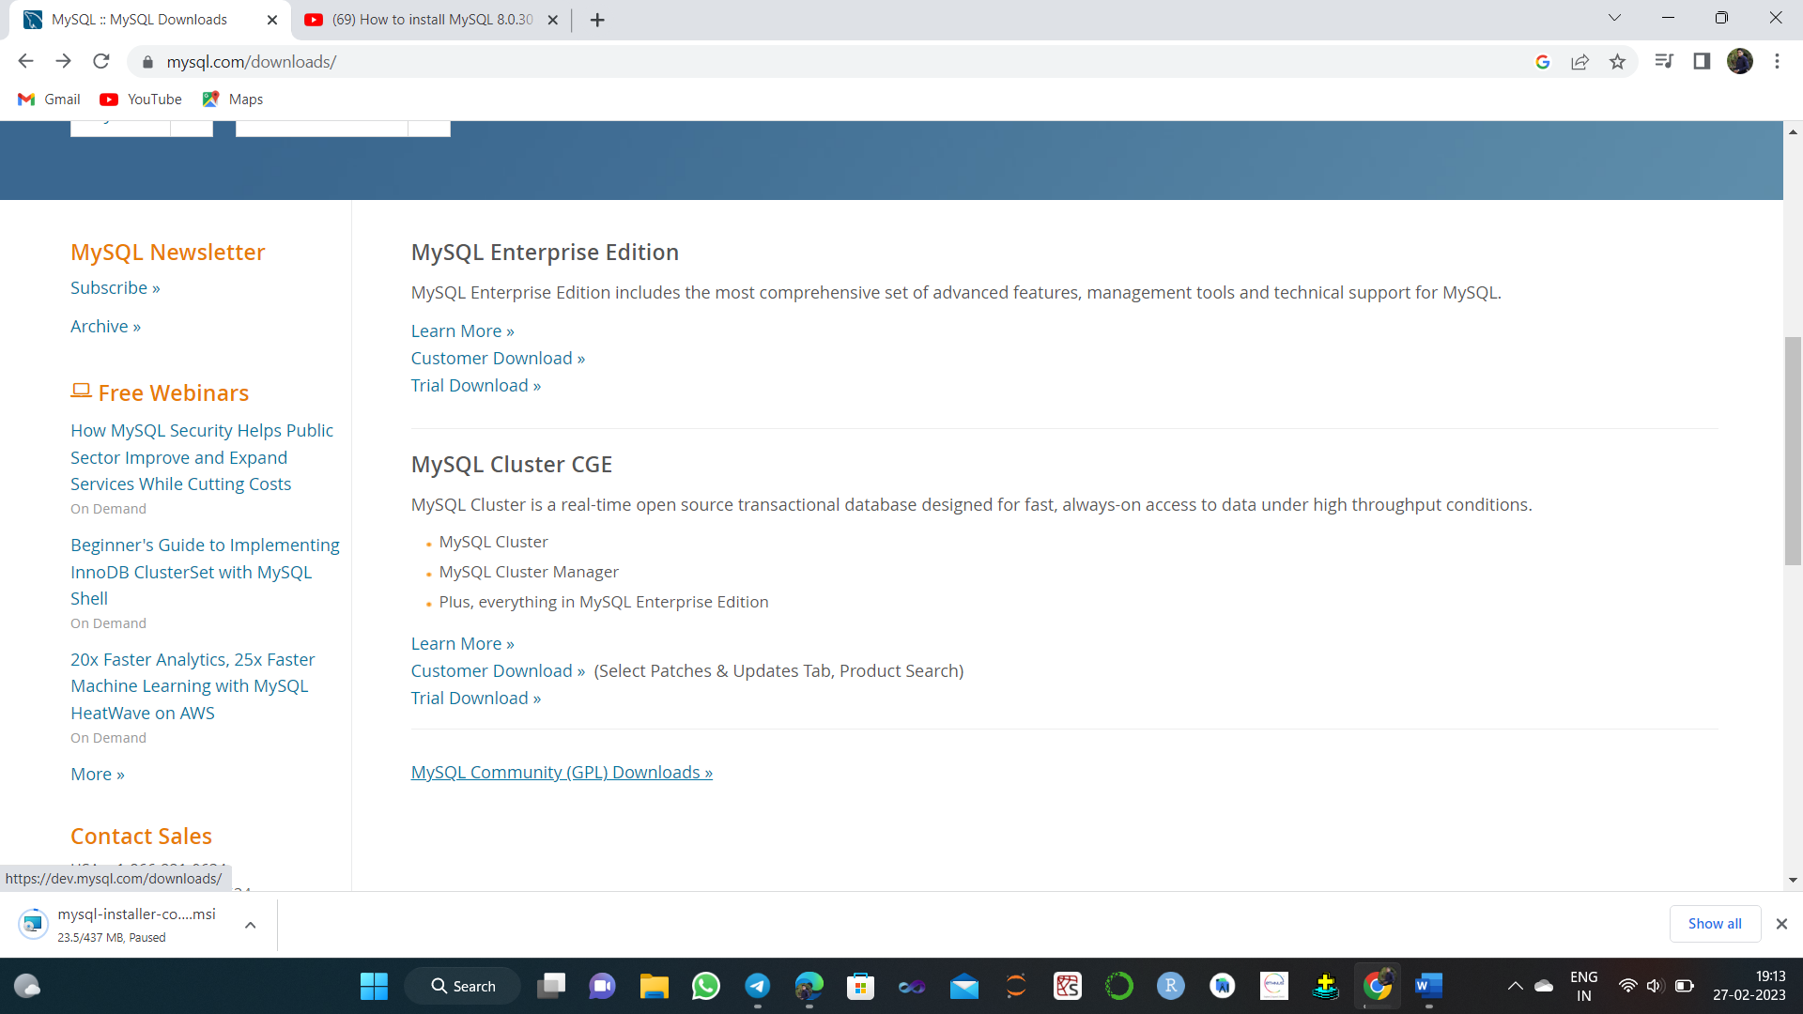

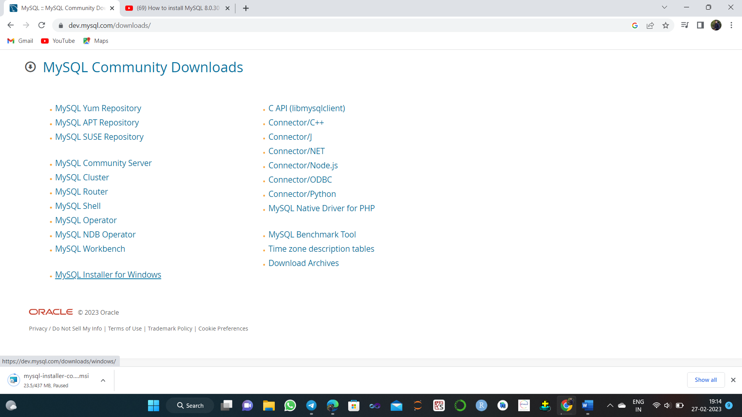

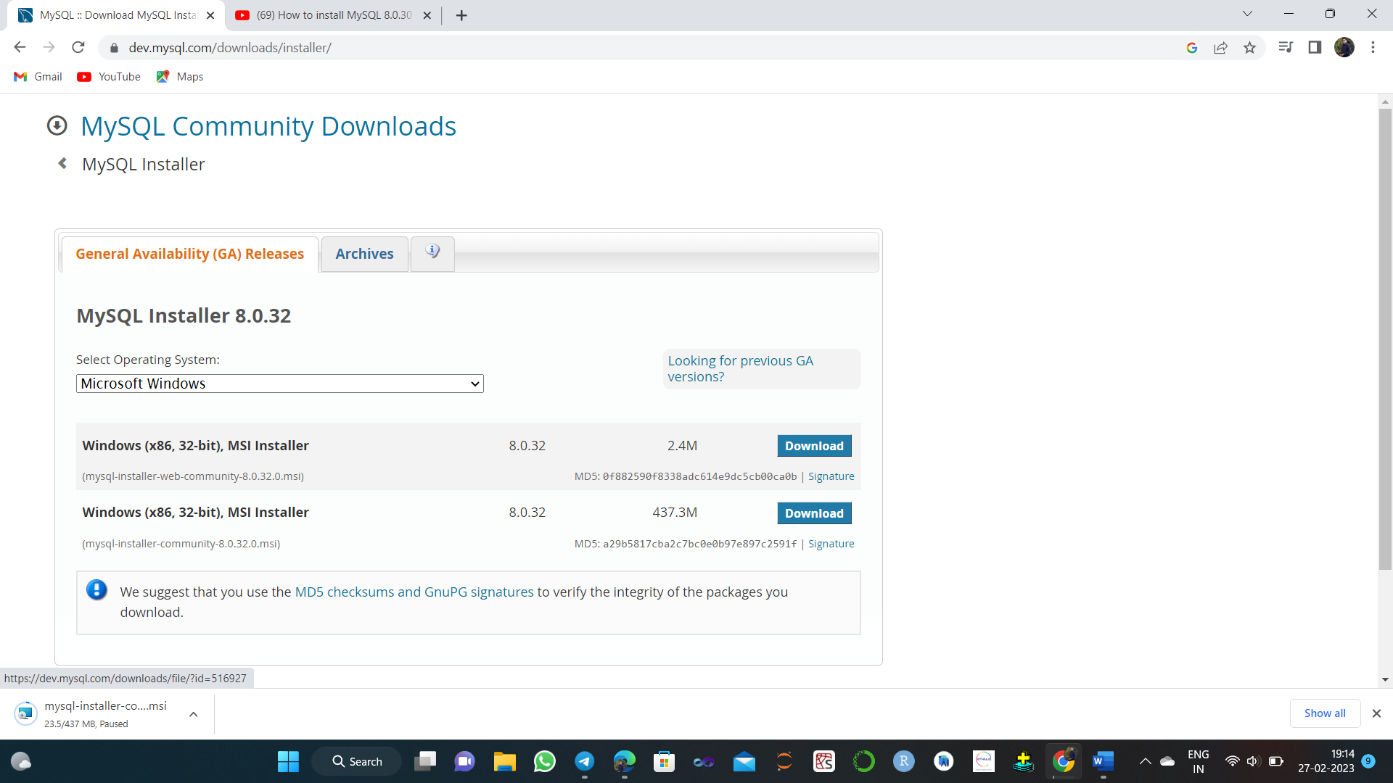

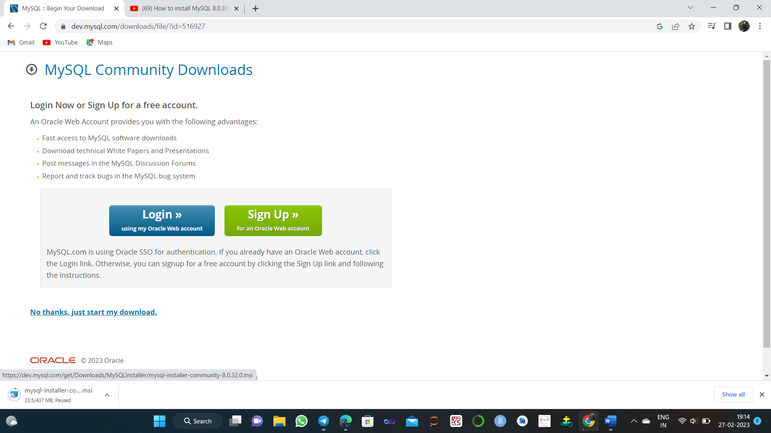

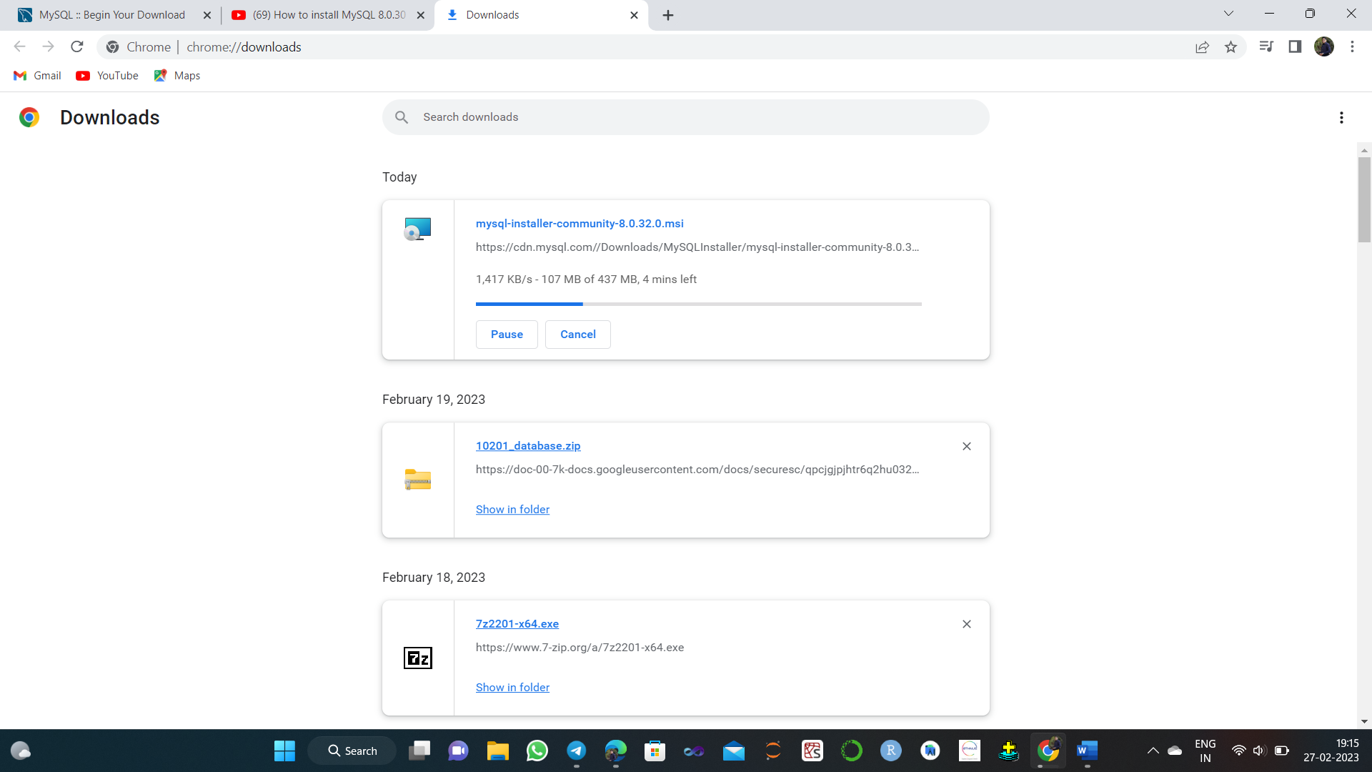

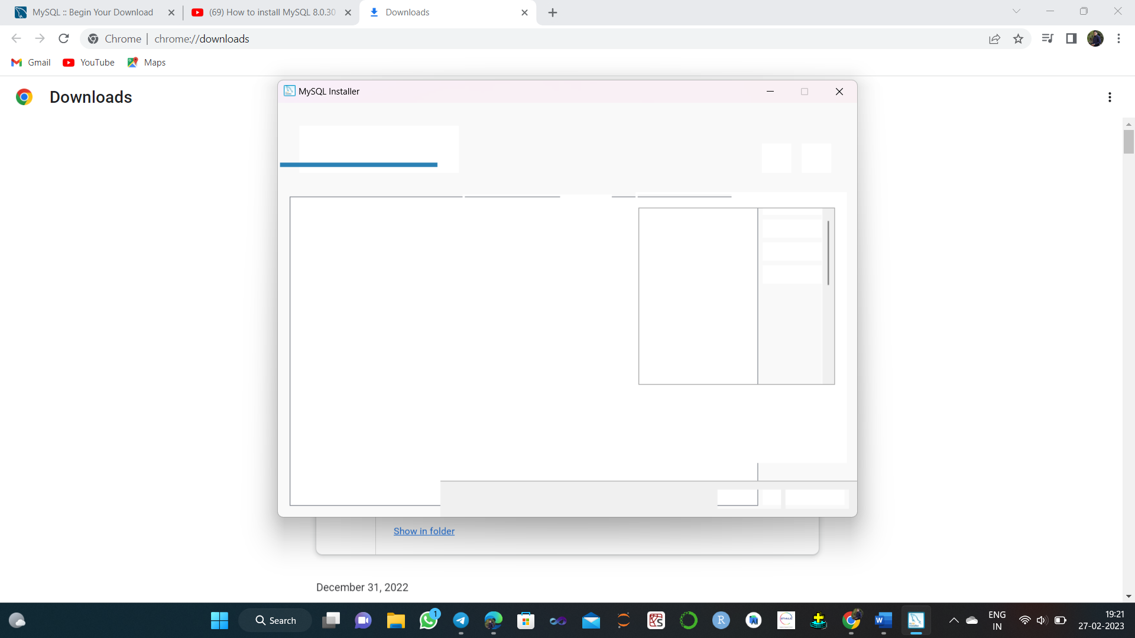

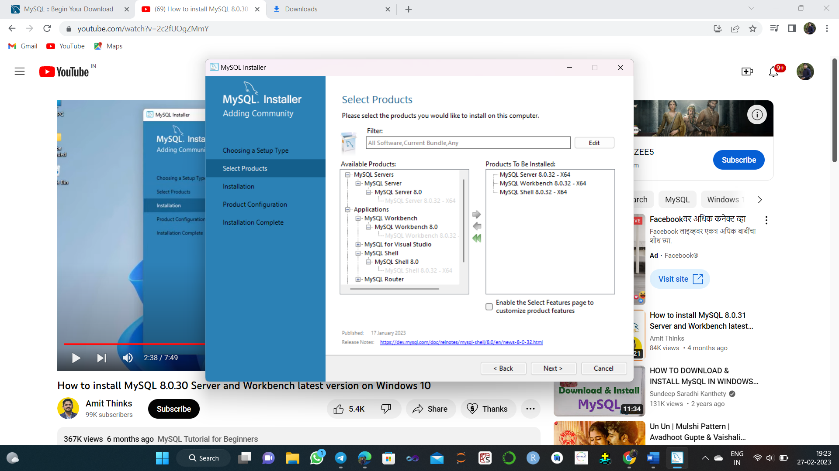

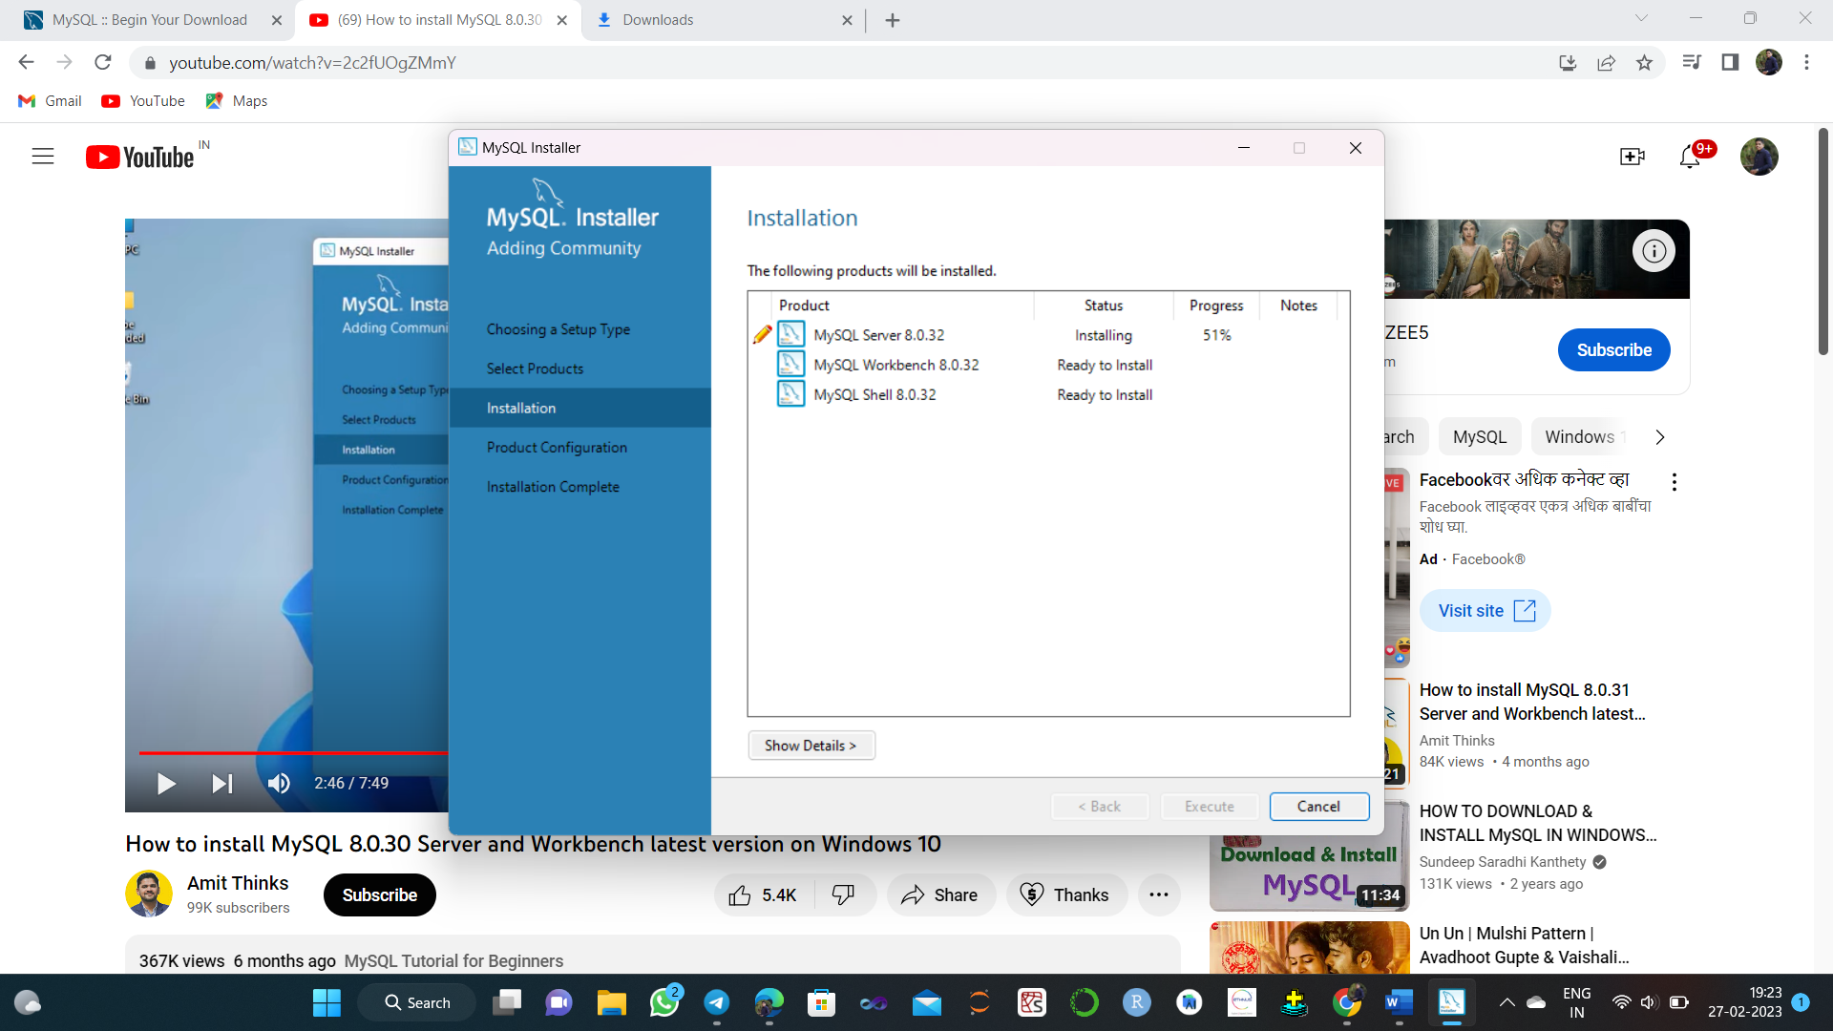

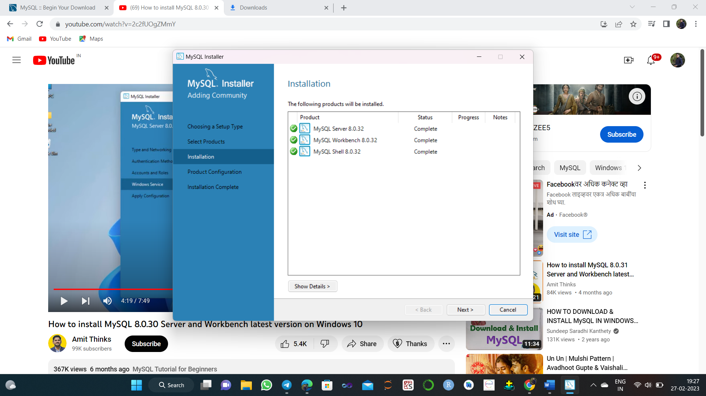

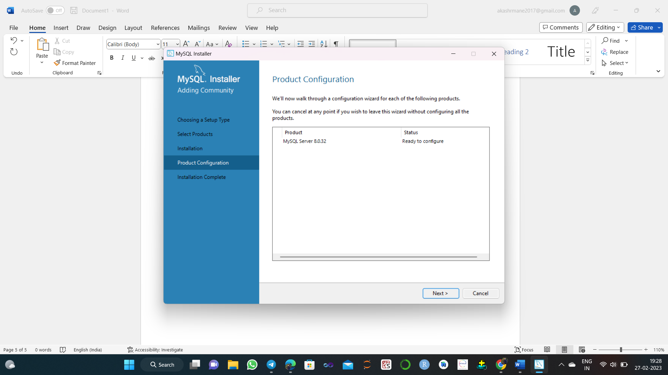

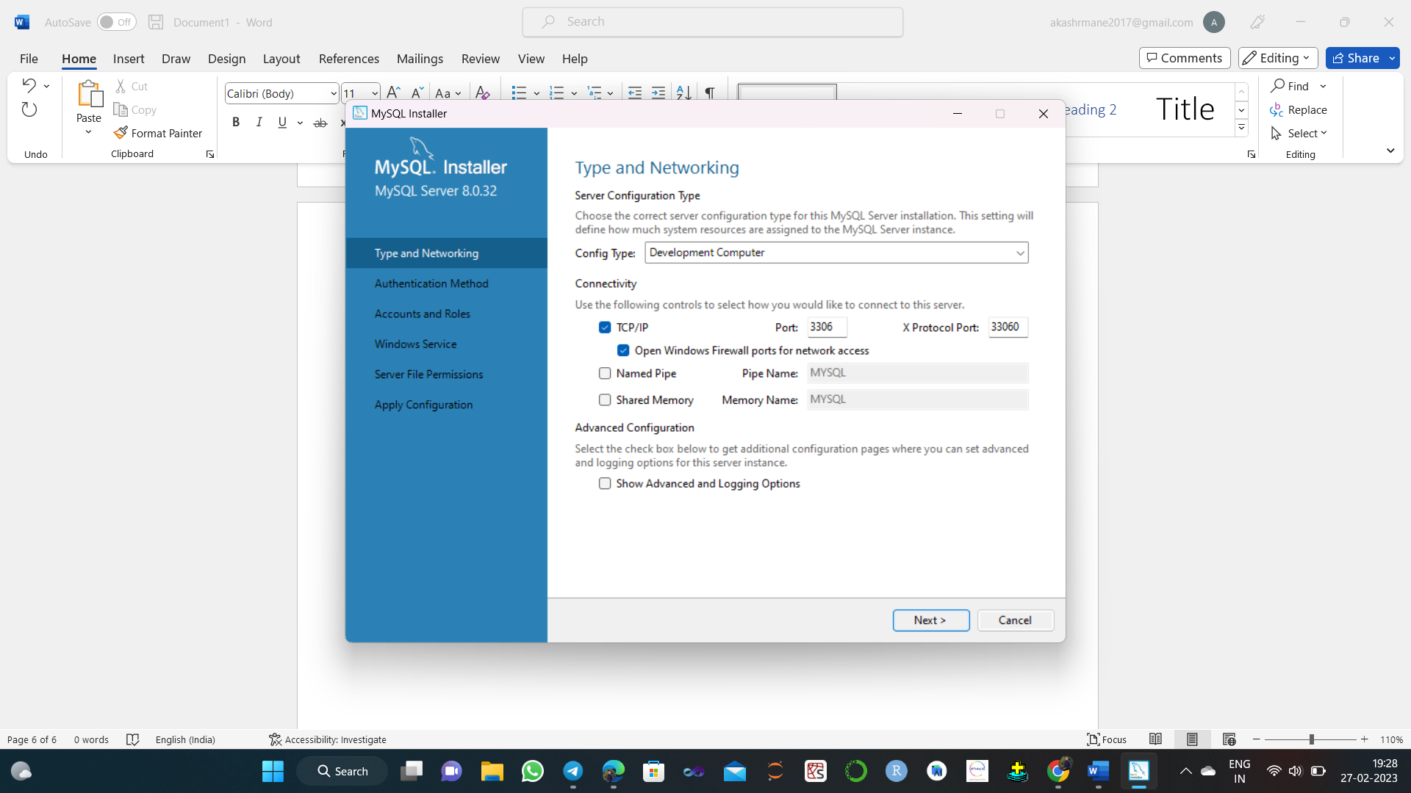

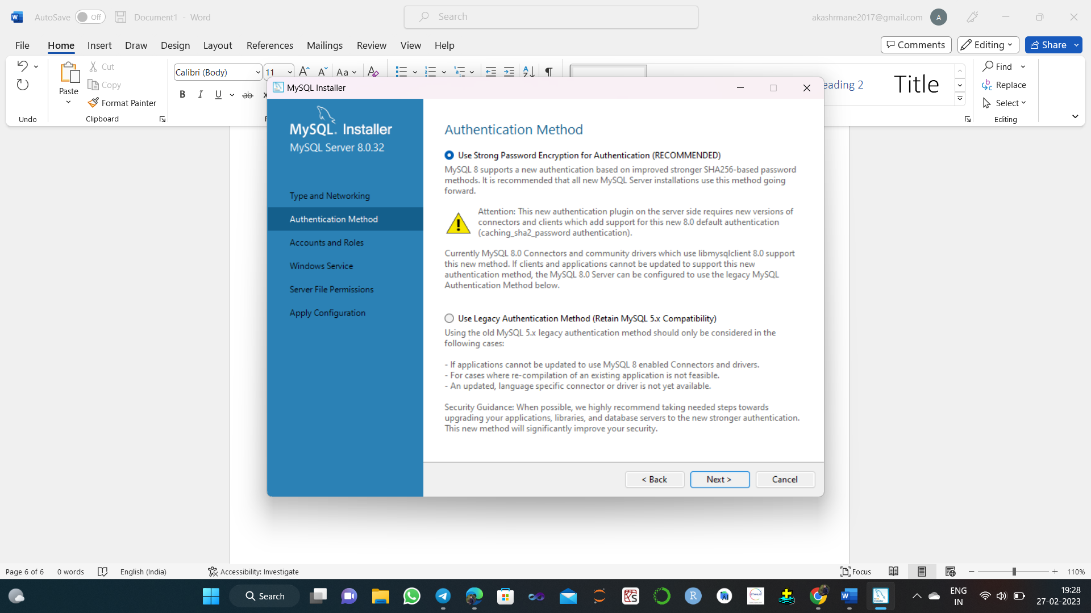

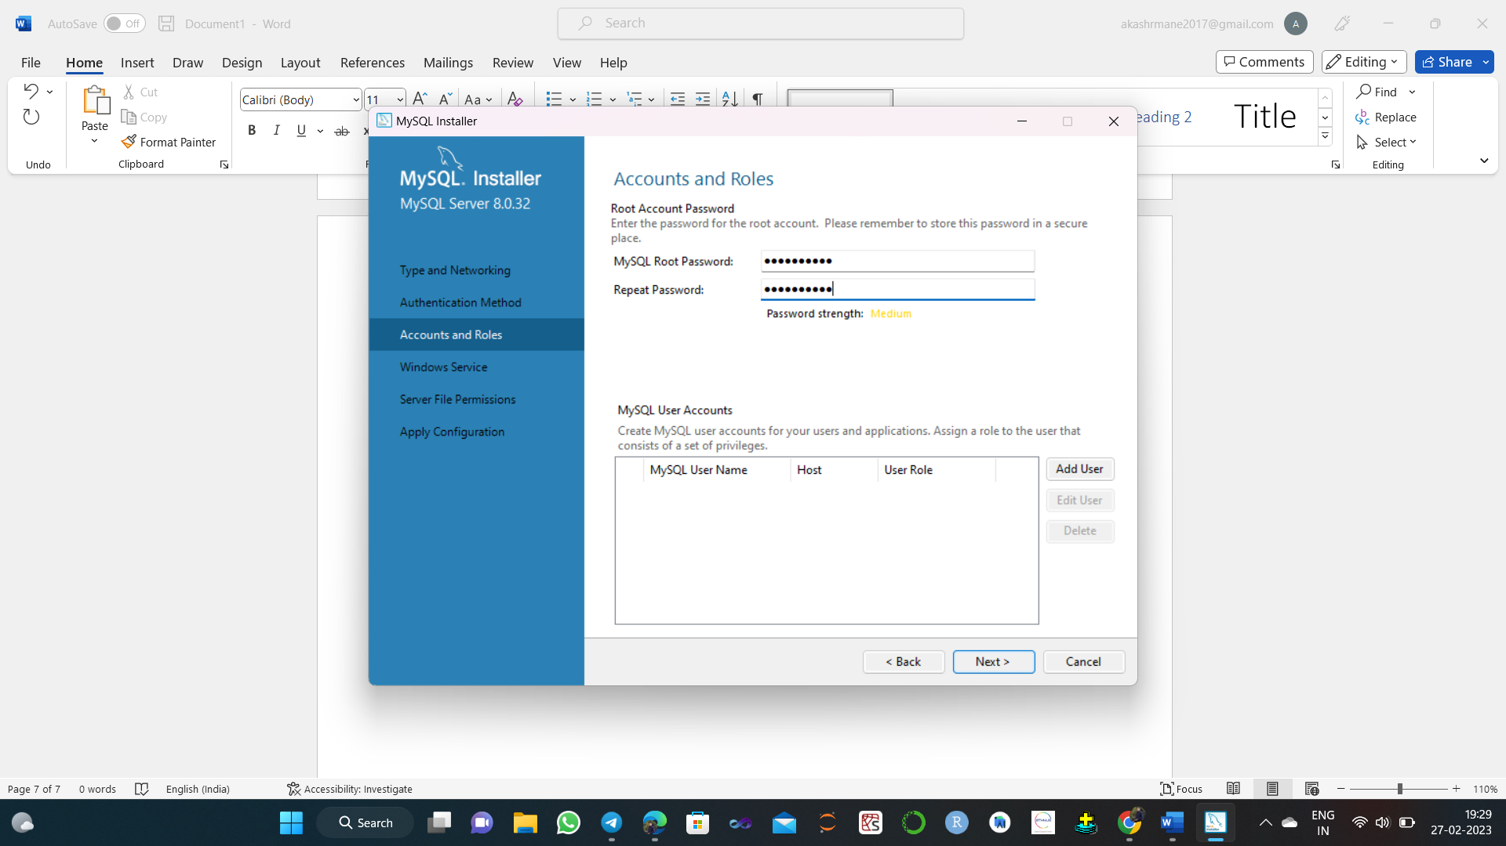

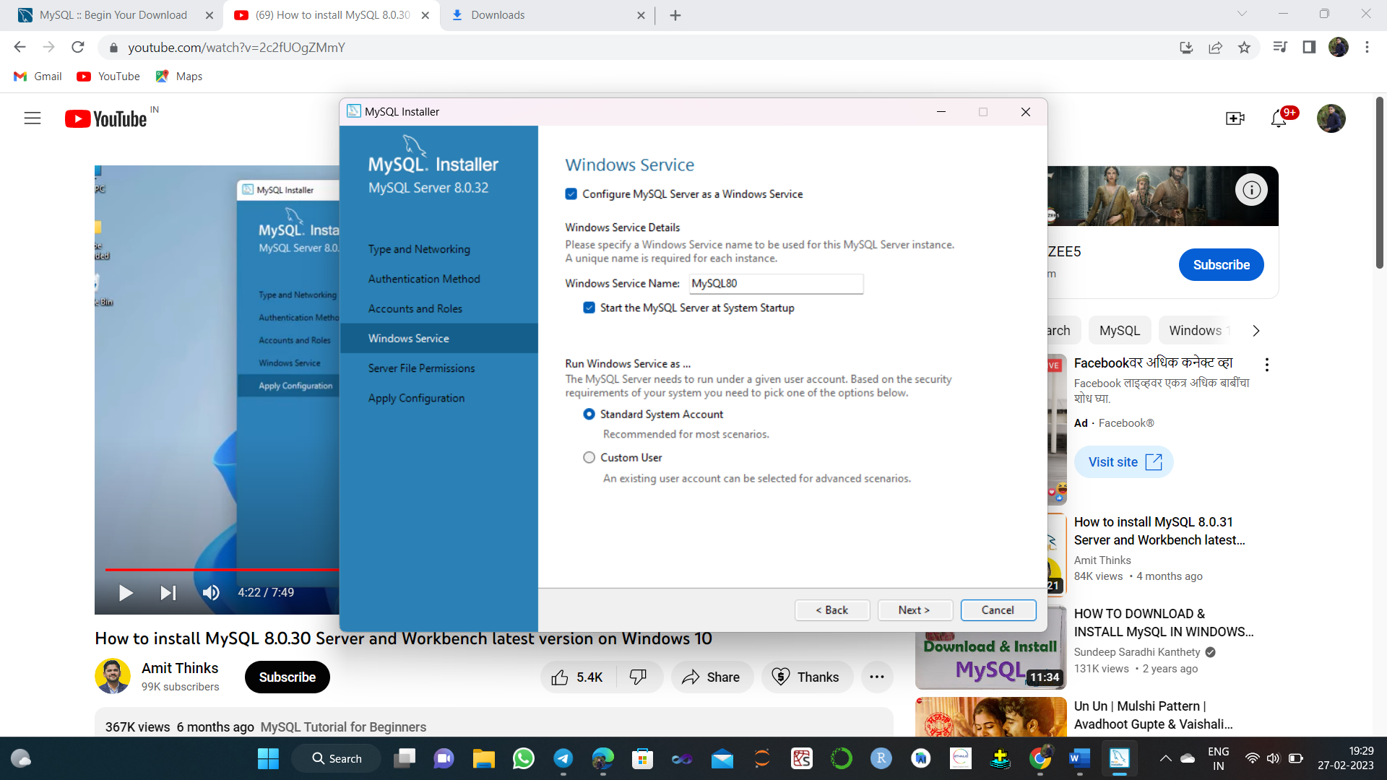

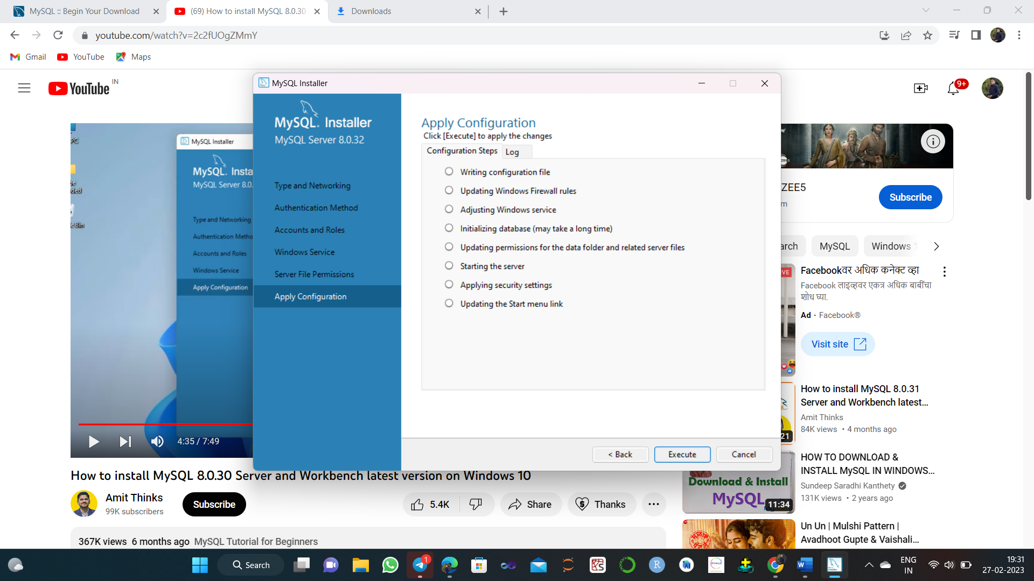

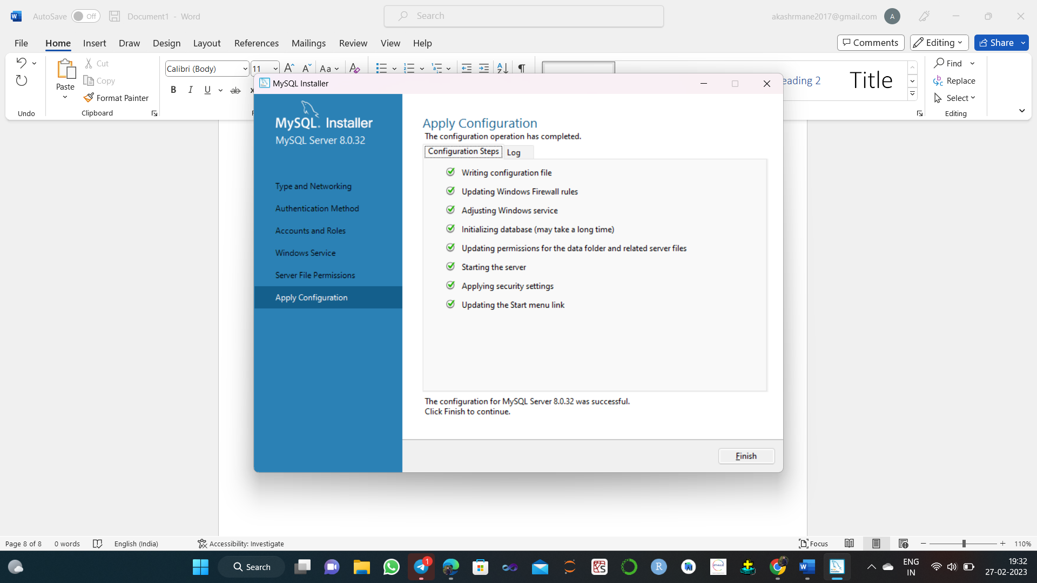

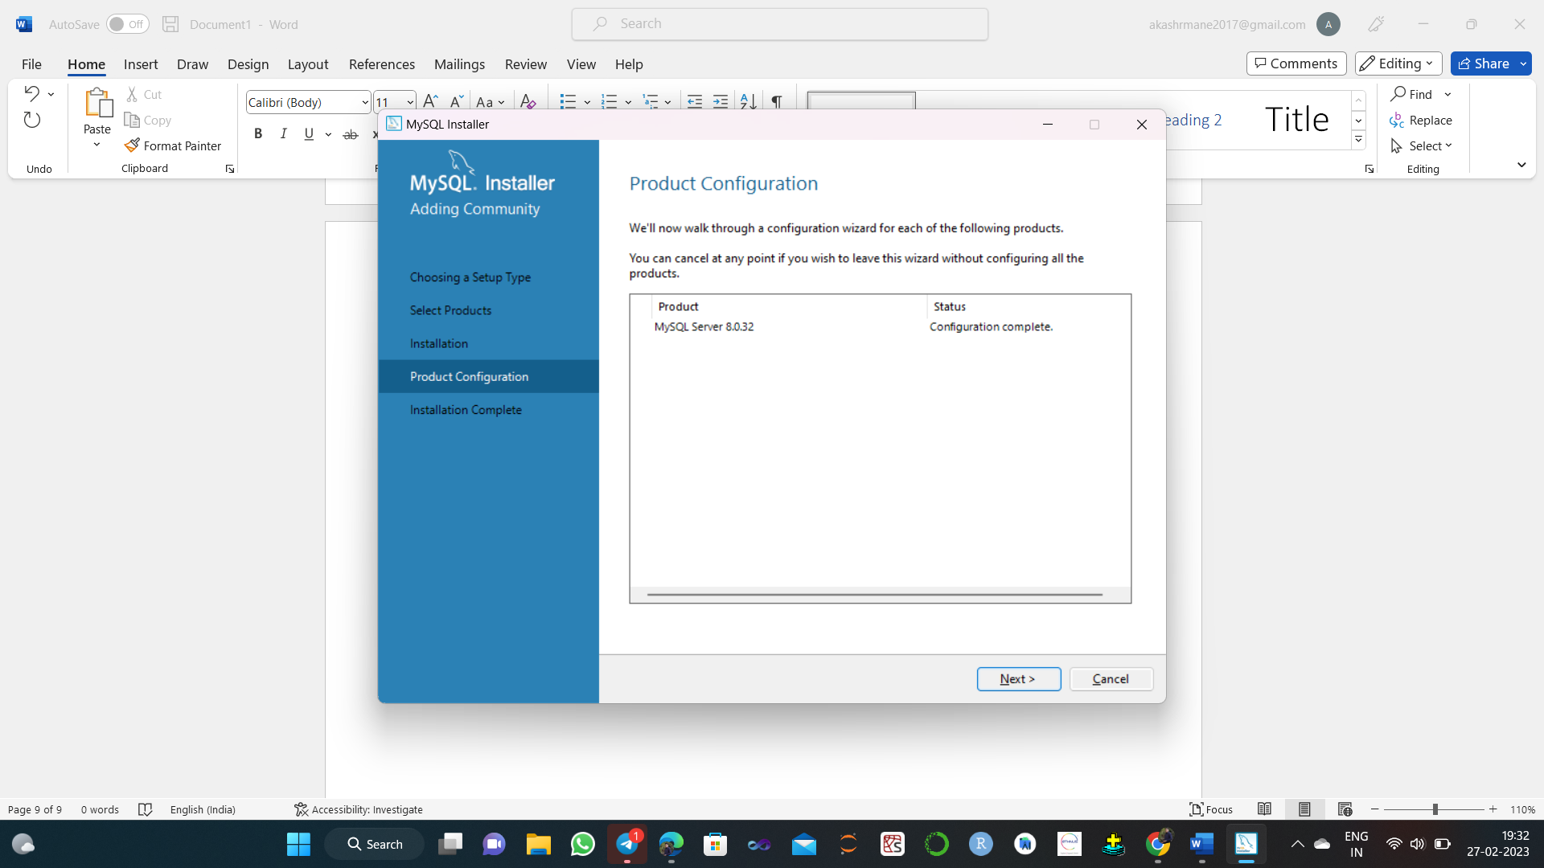

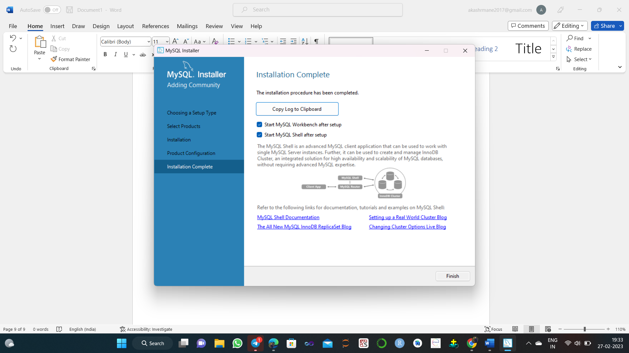

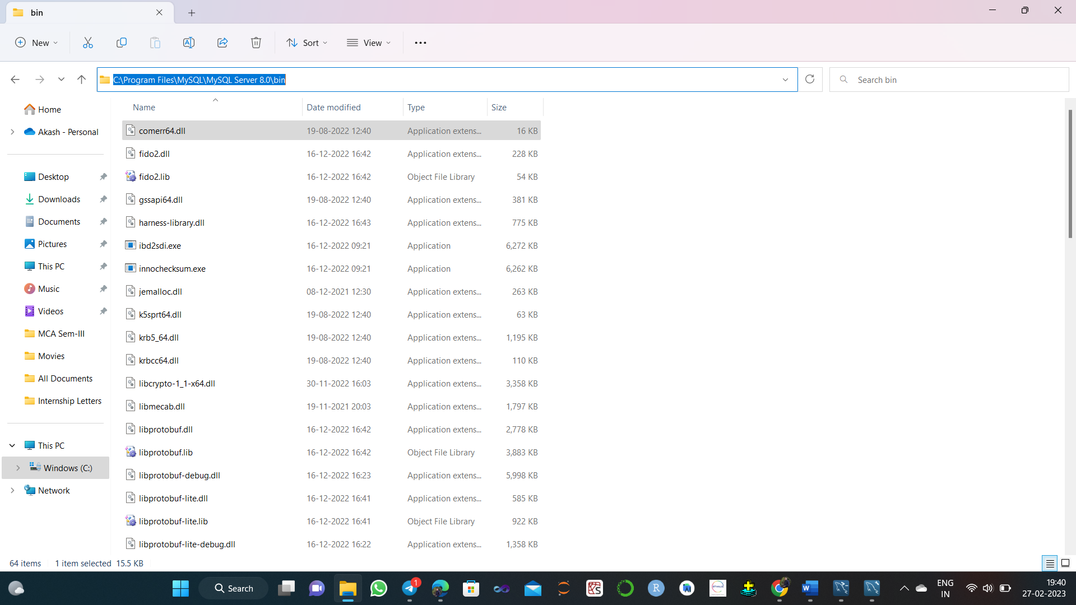

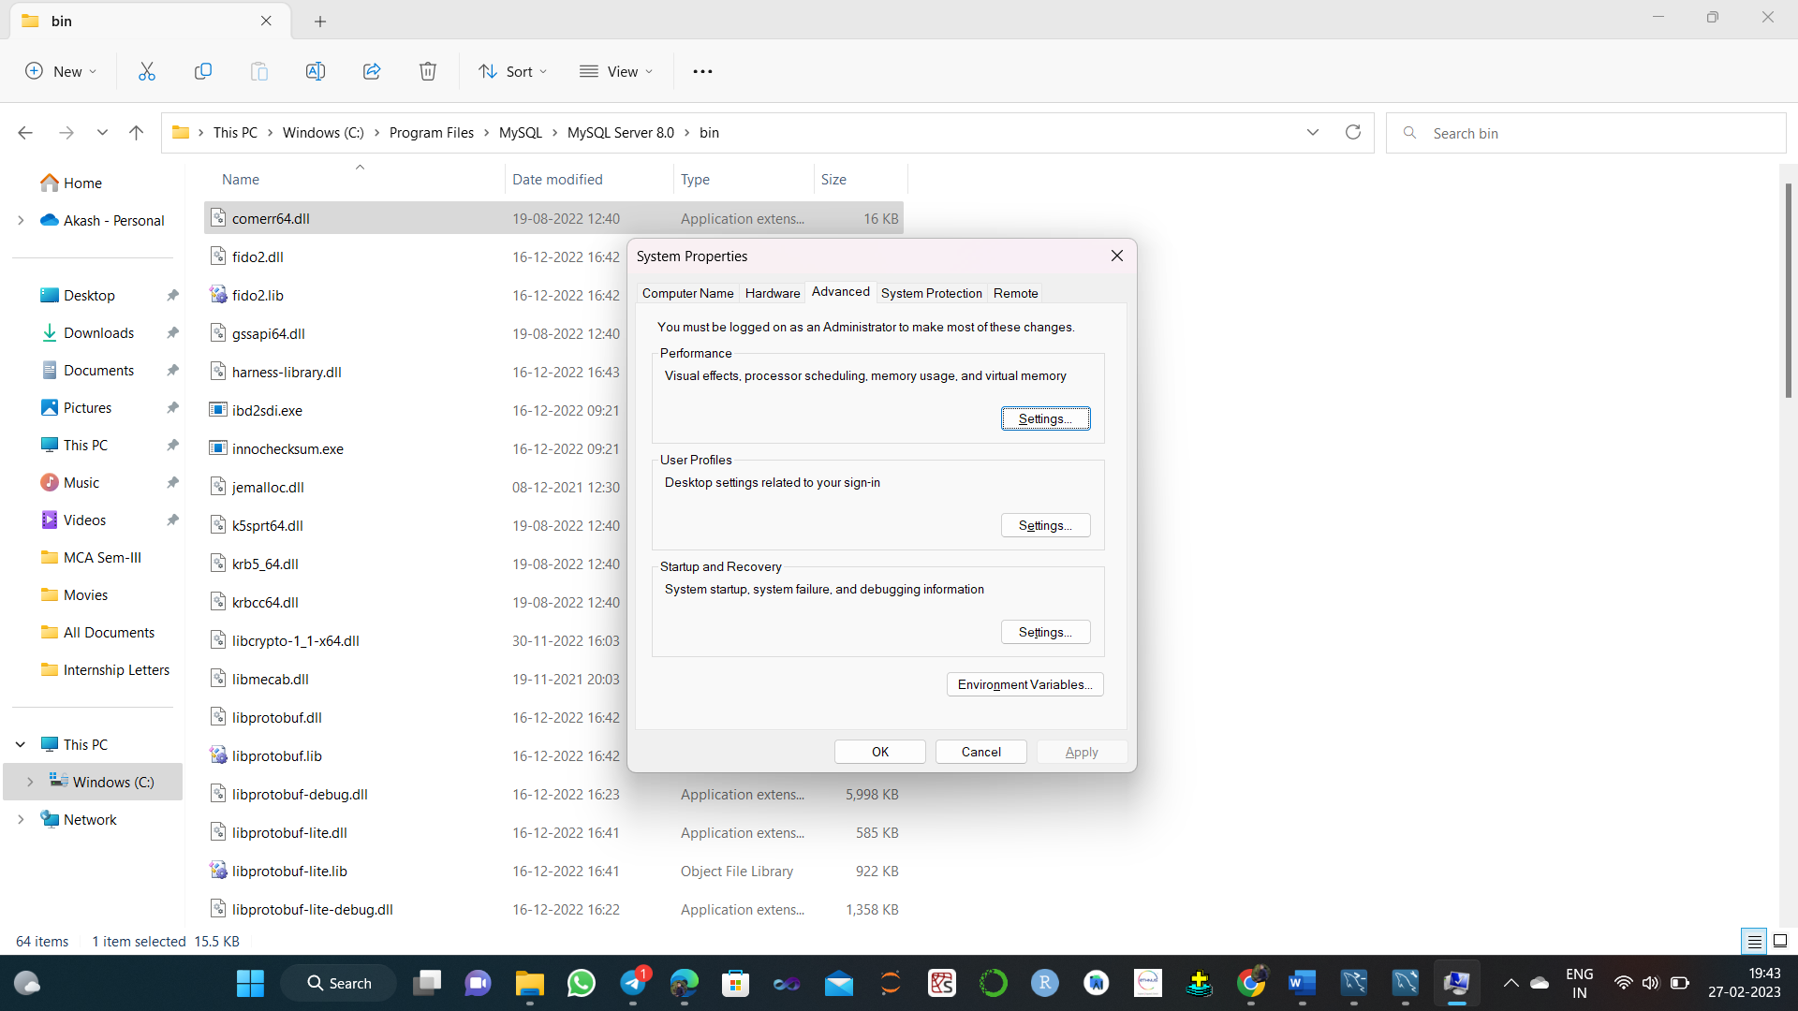

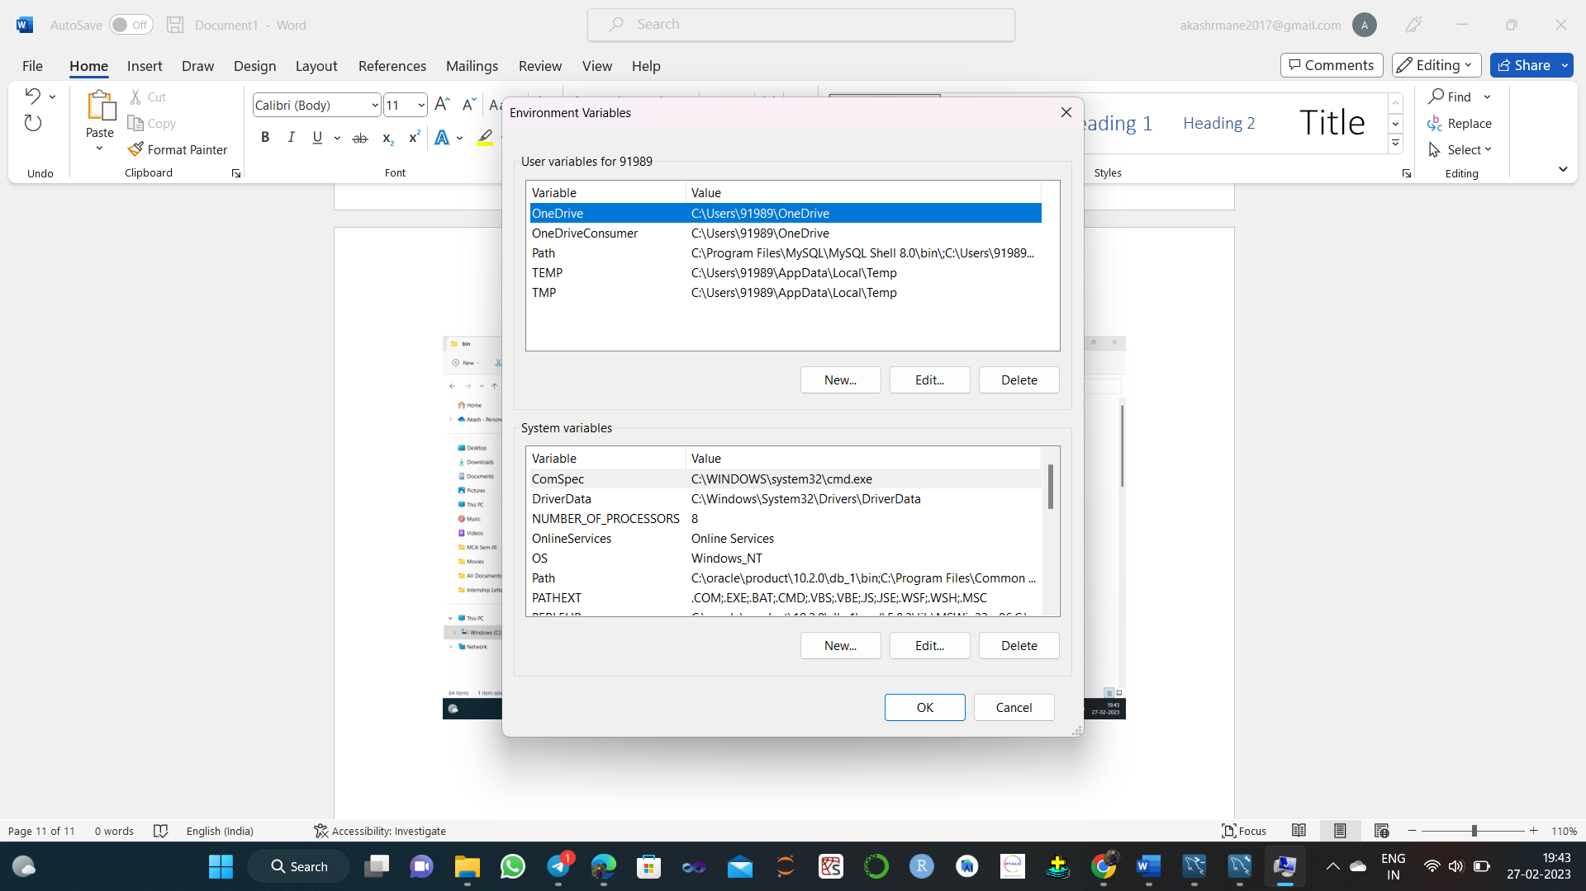

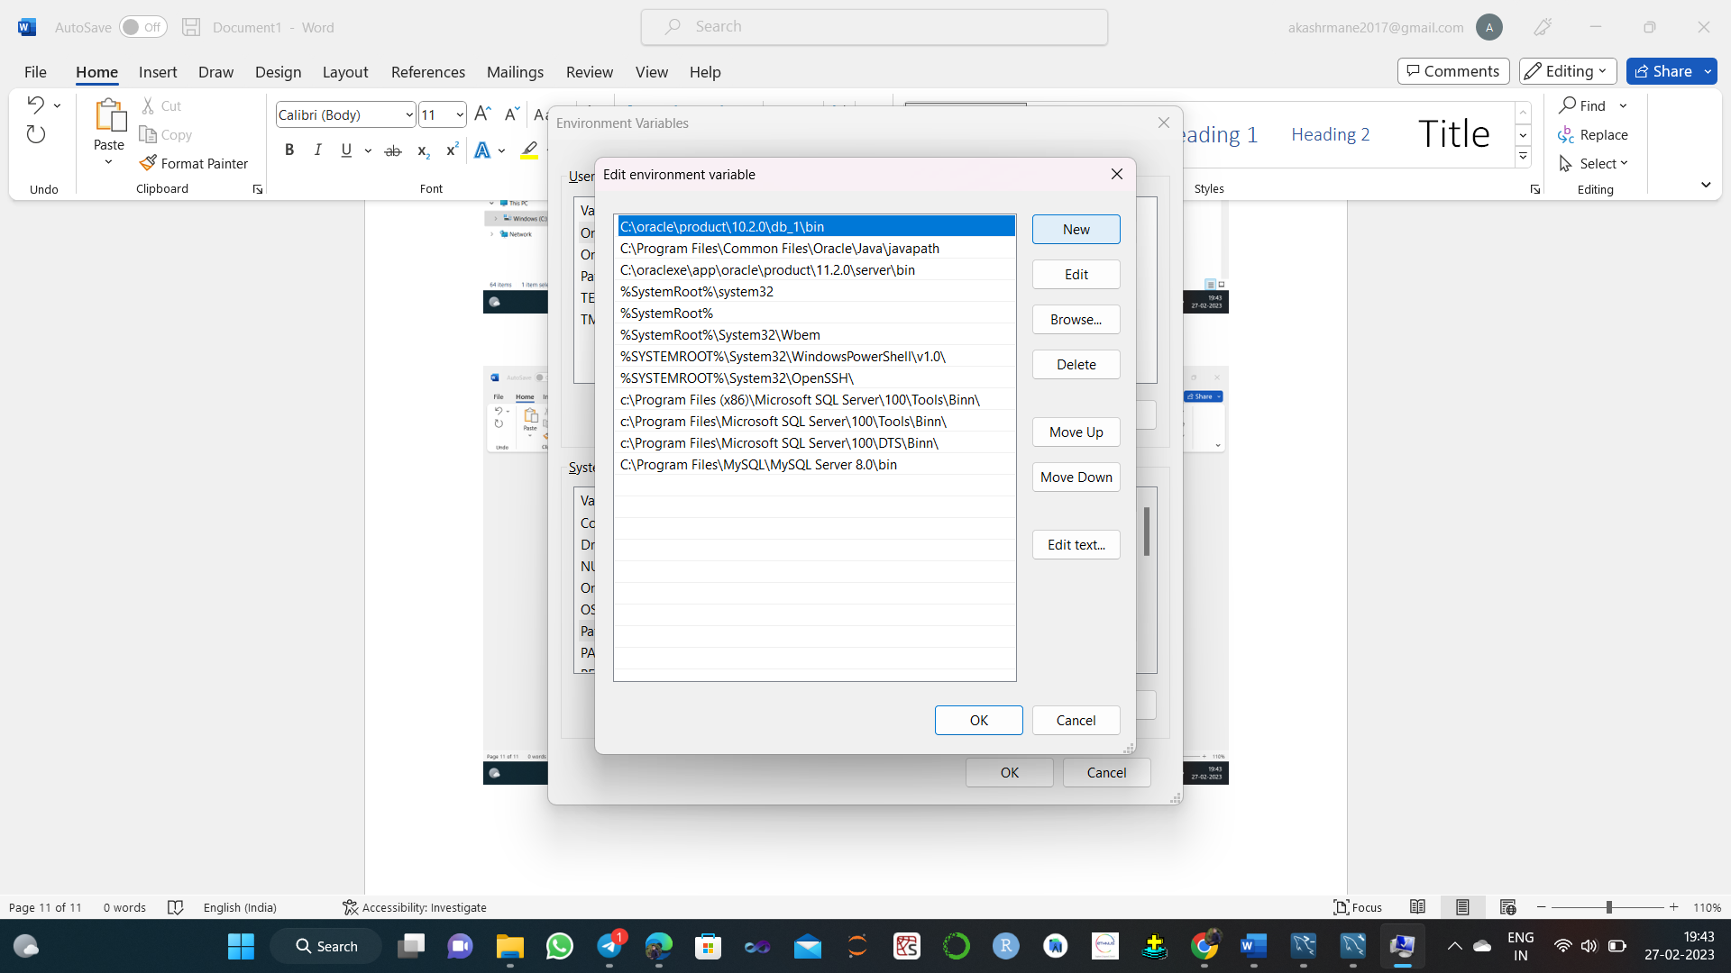

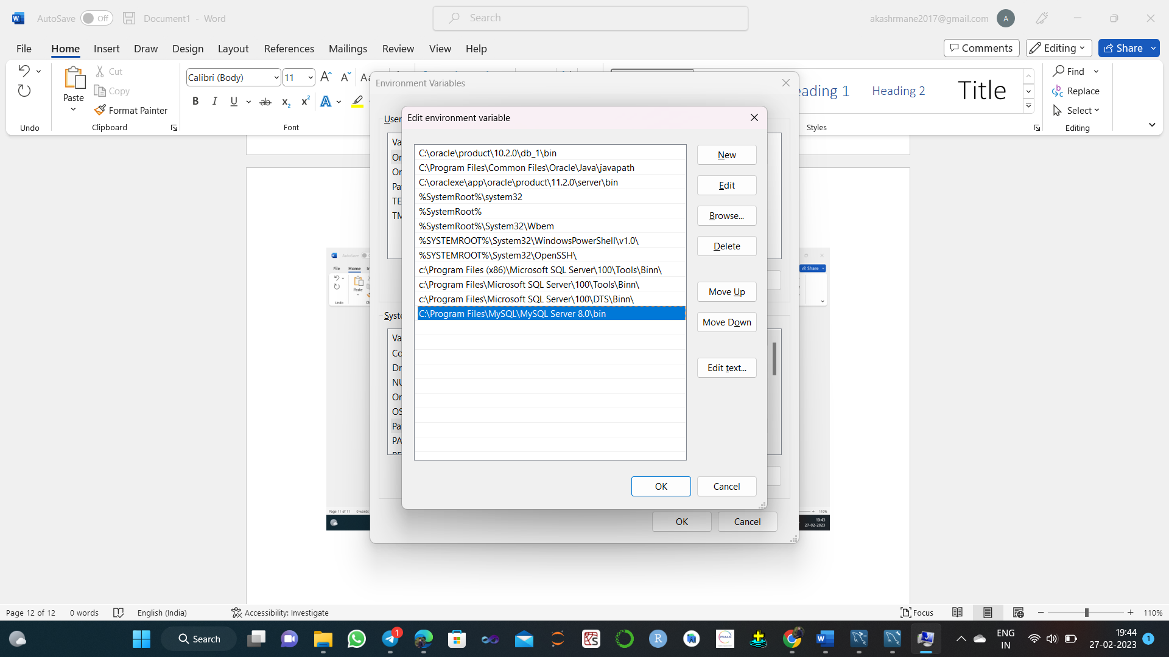

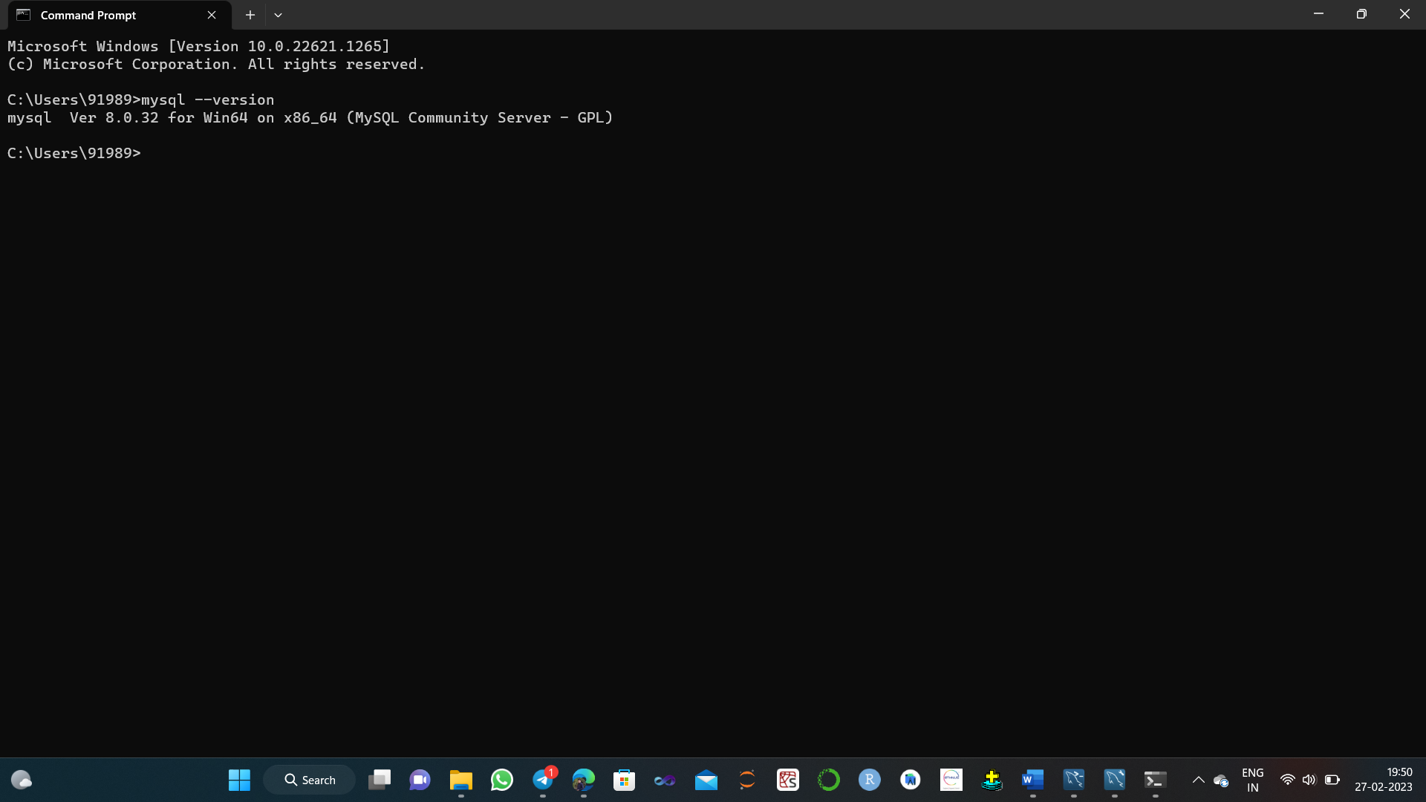

**Q2. What four main types of actions involve databases? Briefly discuss each**

The four main types of actions that involve databases are:

**1 Data Retrieval:** This refers to the process of extracting information from a database. Users can query the database to retrieve specific pieces of information or sets of data. This involves the use of SQL (Structured Query Language) or other programming languages to search for and retrieve the data needed.

**2 Data Modification:** This involves changing the data that is stored in the database. Users can add, modify, or delete data in the database as required. This is typically done through SQL commands that update or delete specific data or sets of data.

**3 Data Backup and Recovery:** This refers to the process of creating backups of the database to prevent data loss in the event of a system failure or other disaster. Backups can be made on a regular basis and stored in a safe location, and can be used to restore the database to its previous state in the event of a failure.

**4 Database Administration:** This involves managing the database itself, including tasks such as configuring database settings, optimizing database performance, and monitoring database security. Database administrators are responsible for ensuring that the database is running smoothly, efficiently, and securely. They may also perform tasks such as creating and managing user accounts and setting up permissions to control access to the database.

**Q3. Discuss the main characteristics of the database approach and how it differs from traditional file systems.**

The database approach is a way of organizing and storing data that is designed to be more efficient, flexible, and secure than traditional file systems. Some of the main characteristics of the database approach are:

**1 Data Independence:** In the database approach, data is stored independently of the programs that use it. This means that changes to the database structure do not require changes to the applications that use the data. This makes it easier to modify and maintain the data over time.

**2 Data Integration:** Databases allow data from different sources to be integrated and stored in a single location. This eliminates data redundancy and inconsistencies that can occur with traditional file systems, which store data in separate files.

**3 Data Sharing:** Databases allow multiple users to access and manipulate the same data simultaneously. This enables collaborative work and reduces the risk of data conflicts that can occur with traditional file systems.

**4 Data Security:** Databases provide security features such as user authentication and access control to protect the data from unauthorized access, modification, or deletion.

**5 Data Consistency and Integrity:** Databases provide mechanisms to ensure that the data is consistent and accurate. This includes constraints such as data types, unique values, and referential integrity, which prevent data from being entered incorrectly or inconsistently.

In contrast, traditional file systems store data in separate files that are organized in a hierarchical directory structure. This approach can be inefficient, inflexible, and insecure. For example, changes to the structure of a file can require changes to all programs that use the file, which can be time-consuming and error-prone. File systems also lack the ability to integrate data from different sources, which can lead to data redundancy and inconsistencies. Additionally, file systems provide limited security features and do not have mechanisms for ensuring data consistency and integrity. Overall, the database approach provides a more efficient, flexible, and secure way to organize and store data than traditional file systems.

**Q4. What is the difference between controlled and uncontrolled redundancy?**

Redundancy refers to the storage of the same data in multiple locations within a database. The difference between controlled and uncontrolled redundancy lies in the way that redundancy is managed:

**Controlled Redundancy:** In controlled redundancy, redundant data is intentionally stored in multiple locations within the database in order to improve performance or facilitate data retrieval. This redundancy is carefully managed to ensure that the data remains consistent across all locations. For example, in a distributed database system, copies of data may be stored at different locations to reduce network traffic and improve response times. However, updates to the data must be carefully synchronized to ensure that all copies remain consistent.

**Uncontrolled Redundancy:** In uncontrolled redundancy, redundant data is stored in the database without any intentional planning or management. This can occur when data is duplicated as a result of poor database design, application errors, or user mistakes. Uncontrolled redundancy can lead to data inconsistencies and can make it more difficult to maintain the database. For example, if the same customer information is stored in multiple tables within a database, changes to one instance of the data may not be reflected in other instances, leading to data inconsistencies.

In general, controlled redundancy is used strategically to improve performance or facilitate data retrieval, while uncontrolled redundancy can lead to data inconsistencies and can make the database more difficult to manage. A well-designed database should minimize uncontrolled redundancy and carefully manage any controlled redundancy to ensure that data remains consistent and easy to maintain.

**Q5. Give examples of systems in which it may make sense to use traditional file processing instead of a database approach.**

While the database approach is generally considered to be more efficient and flexible than traditional file processing, there are still some situations where a file-based approach may be more appropriate. Some examples of systems in which traditional file processing may make sense include:

Small-scale systems: For very small-scale systems, such as personal or small business applications, a database may be overkill. In such cases, a file-based approach may be more efficient and easier to manage.

Single-user systems: If a system is designed to be used by only one user at a time, the benefits of a database approach may be limited. File-based systems may be simpler to implement and may provide adequate performance for such systems.

Static data: If the data used by a system is relatively static and does not change frequently, a file-based approach may be sufficient. For example, a system that stores product information for a small business may not require the flexibility and scalability of a database.

Limited functionality: If a system has very limited functionality, such as a simple calculator application, a file-based approach may be more appropriate than a full database approach.

Low-cost requirements: In some cases, the cost of implementing and maintaining a database may be prohibitive. A file-based approach may be a more cost-effective solution for such systems.

Overall, the choice between a database approach and traditional file processing depends on the specific requirements and characteristics of the system in question. While the database approach is generally considered to be more powerful and flexible, there are still some situations where a file-based approach may be more appropriate.